*\*Hey professor don’t know if you will see the comment in the js code but I was wondering about setInterval(). Everything works, but not being able to pass variables like setInterval(TimeTick(var), 1000) was a big roadblock. Would there be any way to write a code like that in the future?\**

Opening the HTML for the First Time:

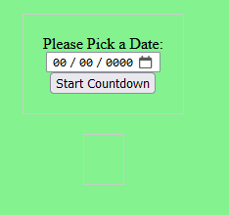

Inputting Date and Pressing Button:

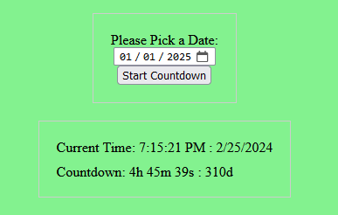

Time actively updating *(sorry hard to convey in screenshots)*:

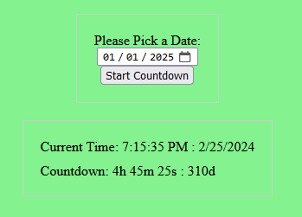

Inputting an Incorrect Date and Hitting Enter:

*\*Note the same thing should appear for the Countdown Reaching the End Date\**

